This is a sample generic opinion writing performance task. Simply modify the highlighted text and add your articles or videos.

|  |  |  |  |
| --- | --- | --- | --- |
| **Teacher Version** | | | |
| **Grade** | **2** | **Title/Subject** | **Type your title here** |

The following sections are included in this Teacher Version:

* **Process: Day 1, 2 and 3**
* **Teacher Directions for Scoring Rubric**
* **Samples of the activities to post on the wall**
* **Student instructions and articles**

|  |
| --- |
| **Overview** |

On Day 1 students will choose which one they like best. On Day 2, after the group activity, they will be directed to plan, and begin to draft an opinion writing piece about which one they like best. On Day 3 students will finish their drafts, revise and edit their writing, and if they choose, produce a final copy.

|  |
| --- |
| **Process** |

**DAY 1: Shared Reading and Planning:** Up to 40 minutes

**Step 1: Connect to Background Knowledge**

Provide an introduction to the classroom activity by indicating that after this activity, students will be writing an opinion piece focused on what they agree or disagree with about the topic. Ask students to share their opinions orally. Possible questions could include:

*“Which do you like best? Why do you like it so much? Do you like other ones too? Why?*

Place words on the wall that illustrate each of the pros and cons of the topic and have students stand next to the one they like best. Samples are provided at the end of this prompt.

For active engagement encourage pair or group sharing, before sharing out with whole group.

**Step 2: Accessing the Information**

1. Explain: *“Now we will learn about this topic.”*
2. Think-Pair-Share: *“Tell your partner what you like about ___________and why”* Make sure both partners have time to share with each other.

Ask your partner questions like these to make sure you have added enough detail:

* Which *___________* did you choose?
* What parts did you like or dislike?
* Why do you think other people would like this *___________*?

**Step 3: Planning:**

Tell students to begin planning their writing on the blank sheet of paper. You can remind them of planning strategies you have taught in your classroom such as outlining, lists, webs, or drawing. You may suggest that they plan to write details about the activity, the reasons they prefer the activity, and who they think would like the activity, but don’t provide a pre-printed plan, just remind them of strategies for planning.

**DAY 2: Writing a Draft:** Up to 40 minutes

**Explain**: *“Today you will have a chance to write a draft to explain to me why you liked or disliked ___________. Tomorrow you will have a chance to change and edit your work from today or add more detail.”*

Review the student directions and checklist for the writing assignment and give each student lined paper for writing. Remind the students to review their plan as they begin to write. Allow up to 40 minutes for writing.

Collect all materials from Day 2.

**DAY 3:** Up to 40 minutes

1. Allow students to access the sources, their notes, the classroom activity charts/key word lists, and their draft.
2. Direct students to re-read their draft from Day 2. Review the task using the student checklist poster. Suggest to students to add reasons and information to their opinion statement about the topic.
3. When students are finished writing, remind them to reread and check for capitals and periods.
4. Collect all student writing materials.

|  |
| --- |
| **Teacher Directions for Scoring Rubric:** |

Use the opinion writing rubric to score the writing and enter a score for each student into assessment log.

|  |  |  |
| --- | --- | --- |
| **Grade** | **2** | **Opinion Writing Rubric** |

|  |  |  |  |
| --- | --- | --- | --- |
| **Level** | **OPINION WRITING/PROCESS** | **LANGUAGE CONVENTIONS** | **WITH GUIDANCE and SUPPORT**  **FROM ADULTS** |
| 4  **Exceeds** | * Meets all expectations in level 3 * Writes several reasons for opinion * Document is well organized and connected * Both opinion and conclusion are clear and well stated | **Mostly correct** use of language conventions, and some above grade level skills used, for example:   * Meets all expectations in level 3 * Uses commas and quotation marks in dialogue. * Spells grade level appropriate words correctly * Chooses words and phrases for effect. | Guidance and Support  Level of guidance and support from adults before writing:  Check off what was done before the student wrote the piece being scored.   * Discussion * Read aloud or shared reading * Drawing * Vocabulary word bank * Shared or interactive writing * Graphic organizer * Language frames |
| 3  **Meets** | **OPINION WRITING** (W1)   * Writes opinion piece about a topic or book (W1) * Introduces the book or topic and states an opinion * Supplies reasons that support opinion * Uses linking words *(because, also)* to connect opinion and reasons * Provides a concluding statement or section   **WRITING PROCESS** (W5-W8)   * **WGASFA\*** Development and organization are appropriate to task and purpose (W4) * **WGASFA\*** Adds details to strengthen writing as needed (W5) * **WGASFA\*** Uses a variety of digital tools to write and publish writing (W6) * Recalls information from experiences or gathers information from provided sources to answer a question (W8) | **Adequate** use of correct sentence formation, punctuation, capitalization, grammar usage and spelling for grade level, for example:   * Produces, expands, and rearranges complete simple and compound sentences (L1f) * Creates readable documents with legible print (L1g) * Capitalizes holidays, product names, and geographic names (L2a) * Uses commas in greetings and closings of letters (L2b) * Uses an apostrophe to form contractions and frequently occurring possessives (L2c) * Consults reference materials as needed to check and correct spellings (L2e) * Spells grade level appropriate words correctly most of the time, uses grade level appropriate phonetic spelling to write unfamiliar words * Uses knowledge of language and its conventions when writing (L3) |
| 2  **Almost Meets** | * Names topic or book * Gives 1-2 reasons * Adds few details * Uses few or repeats linking words * Provides a conclusion but may not be well related | **Limited** use of correct sentence formation, punctuation, capitalization, grammar usage and spelling for grade level, for example:   * Writes simple sentences, and some incomplete sentences * Capitalizes first letter, and I, but not proper names * Uses some punctuation correctly * Spells some grade level appropriate words, and uses some phonetic spellings |
| 1  **Does Not Meet** | * Does not name topic or book * Provides no opinion or reasons for opinion * Provides no concluding statement | **Infrequent** use of correct sentence formation, punctuation, capitalization, grammar usage and spelling for grade level, for example:   * Makes few attempts at correct spelling * Has many errors in capitalization * Writes few complete sentences or only simple patterned sentences * Makes few attempts at correct punctuation |

* **WGASFA**: “with guidance and support from adults”

This rubric was adapted from rubrics at sbusd.org and information from Smarter Balanced Assessments (www.**smarterbalanced**.org) using the California Common Core Standards at www.cde.**ca**.gov.

**I like:**

**Place your text or example here**

**I DO NOT**

**like:**

**Place your text or example here**

|  |  |  |  |
| --- | --- | --- | --- |
| **Student Version** | | | |
| **Grade** | **2** | **Title/Subject** | **Type your title here** |

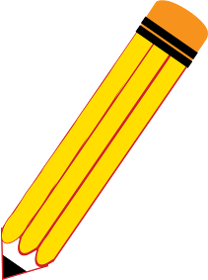



Good work!

As you think about what we just read, write to explain to me what your opinion is about this topic.

* Be sure to name your topic or book.
* Introduce your topic and state your opinion.
* Write **at least 2 reasons** to support your opinion.
* End with a **concluding statement** or section.
* 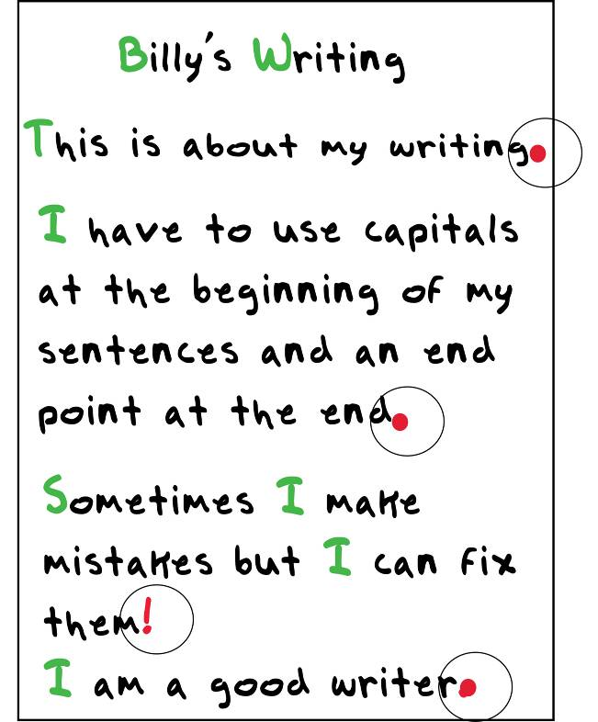You can look at the sources and our key word list to help you with your writing.
* You may want to draw a picture on the planning page to help you with your thinking.
* **Do not copy sentences** from the sources.
* Does your writing make sense?

***Be sure to…***

* + Use **capitals** at the beginning of sentences
  + **Capitals** for proper nouns
  + Use **end points** at the end of your sentences **. ! ?**
  + Apostrophes ‘ for contractions and possessives (*don’t, won’t*)
  + Check your spelling (dictionary)
  + Try to use complete sentences
  + Use linking words such as *because* or *also* to connect your opinion and your reasons
* Fix your mistakes.
* Make sure to leave spaces between your words.
* Use your neatest handwriting or printing.

|  |  |  |  |
| --- | --- | --- | --- |
| **Student Reading Text** | | | |
| **Grade** | **2** | **Title/Subject** | **Type your title here** |

**Include your articles/information here**