Constructed Response Questions – Grade 6 2013-2014
From SBAC portal – Practice Test Scoring Guides at SBAC.com

Cure It with Candy
by Bart King

Humans of all ages get hiccups. Even animals can suffer from hiccups. Because hiccups are so common, you’d think doctors would know why we get them. But even among medical experts, there is no agreement about what exactly causes hiccups—nor about how to cure them.
A hiccup happens when the diaphragm, a muscle inside your ribcage, contracts. Different events cause the diaphragm muscle to tighten and shorten. For instance, swallowing a fizzy drink bloats the stomach. The pressure from the bloating causes hiccups. Another hiccup trigger is eating spicy foods. Even being surprised or scared can give you the hiccups!
When a hiccup strikes, it also affects the throat and upper body. The hiccuper takes in a quick breath. The back of the hiccuper’s tongue moves up, and the throat clamps down. This is what makes the hic sound. Other muscles in the neck and chest shorten and tighten. Finally, the hiccuper’s heart slows for a moment. Then, after a few seconds, the whole process starts all over again. Hic! Hic! Hic!
Some people rarely—if ever—get hiccups, and when they do, the hiccups do not last long. For them, hiccups are just a nuisance. Other people can suffer hiccups over and over, for hours or days on end. For them, hiccups are a real problem. (Imagine sitting in a quiet classroom while you have the hiccups.)
What is the best treatment to cure hiccups? There is no sure-fire cure. People try all kinds of remedies, such as eating sugar cubes or honey, and sipping from a glass of water while leaning over (so the head is upside- down).
During a tough attack of the hiccups at the age of 11, a girl named Mallory Kievman tried to cure her hiccups with every method she could think of. She even sipped from a jar of pickle juice. Mallory was surprised that there was no reliable cure. This launched her investigation of home remedies. She discovered about a hundred hiccup cures and began testing them in her family’s kitchen.

After tossing out the useless remedies, Mallory determined there were three effective cures: eating sugar, sipping apple cider vinegar, and sucking on a lollipop. She combined these elements into a single product: a hiccup- stopping candy that Mallory called Hiccupops.

Mallory took her lollipop idea to an invention convention for kids. Her Hiccupop impressed the judges so much that Mallory walked away with the top prize. Part of the prize was a patent on the Hiccupop. A patent gives an inventor the full legal rights to his or her creation. Having a patent meant that the Hiccupop was Mallory’s legal property. It was hers to keep—or hers to sell.
In order to sell the sucker, Mallory had to fine-tune the recipe. Flavor would be important to shoppers. The Hiccupop mixture would have to be stable. Mallory knew the lollipop needed to last on store shelves. No one would buy the lollipop if it melted or became gummy. To achieve a stable mixture, Mallory had to learn about the science of mixing the ingredients.
Many messy experiments later, Mallory continues perfecting her Hiccupops recipe. She has also learned that the lollipop might be especially helpful to hospital patients. Some patients get hiccups as a side effect of medicine. Now doctors can offer Hiccupops as part of the treatment plan.
Mallory Kievman is already a successful inventor, but she’s decided on a different career for her future. She wants to be a doctor. After all, she already has a head start at becoming a hiccup specialist.

Type your answer in this box.

Libby’s Graduation
by M. G. Merfeld
It was final exam day—for my dog. And I was nervous.

It all started a few months ago when my mom and dad made a deal with me. After years of hearing me pester them about our need for a dog, they agreed to get one if I promised to care for it, train it, and love it.
“The dog will be your responsibility,” Dad warned, “—and not just when it’s convenient.”
Libby, a four-month-old yellow Labrador retriever, arrived shortly thereafter. She was a 30-pound ball of fur, claws, and teeth with an uncanny ability to jump, dig, and chew.
“I think she is part-kangaroo,” I said as she bounced up and down on her hind legs to greet me.
She could also run like a racehorse. Each day after school I exercised Libby by taking her for long walks or by repeatedly throwing a tennis ball for her to chase down. When it was too wet to play outside, I lobbed an assortment of furry, squeaky toys up and down the stairs for her to retrieve. She never seemed to tire.
When Libby was six months old, Dad enrolled her in a puppy training class. I was to accompany them each Saturday for five weeks to learn how to train Libby to behave properly.
On the first day of dog school, Libby was as excited as I had ever seen her. She howled and whined and stood on her hind legs when she saw the other dogs in the class. Her tail wagged at about 100 miles an hour as she ran and greeted each of her canine classmates.
“If we could harness her tail’s energy,” my dad said, “I think she could generate enough power to light up a small city.”
Despite the distraction of having four potential playmates in the room, Libby breezed through her first class because we had already taught her to sit, lie down, and recognize her name. My homework was to reinforce these ideas throughout the week.

Weeks 2 and 3 were more difficult. We were tasked with training Libby to avoid jumping on people when she met them and to walk on a leash without tugging ahead. When she was introduced to these concepts in class, she responded the way she usually did: she leapt on every dog owner in the class and pulled me around the room like she was leading a team of Alaskan sled dogs.
“Dad, she’s not getting it,” I told him a few days later. “She’d rather greet people and lick them to death than stay down and get a treat.”
“You have to work with her more,” he told me. “She’ll come around.”

When I objected, saying I didn’t have enough time because of baseball practice and homework, my dad gave me his serious look. All he said was, “Remember our deal.”
That was enough for me. Our trainer said we were supposed to keep a “smile” in the leash when we walked, meaning there should be some slack between the owner and the dog. My leash was more of a tight-lipped grin. On our training treks down the street to the park, I frequently commanded Libby to “stop and sit” when she forged ahead. Libby would obediently sit and wait; then she would charge ahead. With so many starts and stops, our 15-minute walks stretched to half an hour.
I grudgingly missed a trip to the water park with my best friend for week 4, so I was not the happiest owner at the class. But the teacher said it was the most important class of the series because she was going to talk about the commands to “stay” and “come.”
“Teaching your dog to come when she is called can save her life,” she said. “If she takes off chasing something into a dangerous area, she has to respond to your call.”
She was right. I had seen Libby bolt across the street once while chasing a squirrel, and I was glad we lived on a quiet street with little traffic. So I worked extra hard on our homework that week.
Now, it was time for her fifth class—her final exam and, hopefully, her graduation. It seemed strange that I was so nervous for Libby’s final test. I wondered what would happen if she failed. Do dogs flunk?

When Libby’s turn came, she nailed the sit, lie down, and stay commands. When I told her to stay and I crossed the room, she waited
patiently, ignoring the other dogs, tilting her head to one side, and fixing her eyes on mine until I told her to “come.” It was impressive. We made our
way through the cones pretty well, too, with only a couple of brief “stops” needed when Libby pulled the leash ahead of me.
At the end, the teacher applauded. “I definitely think Libby gets the most improved award,” she announced.
I hugged Libby and gave her a jackpot: five sausage treats. “Way to go, Libs,” I said as she licked my cheek. I could smell the sausage all over my face, but I didn’t care. “I’m so proud of you.”
My dad put his hand on my shoulder and patted Libby on the head. “I’m proud of both of you.”

“Libby's Graduation” by M. G. Merfeld. Copyright © 2012 by CTB/McGraw-Hill.

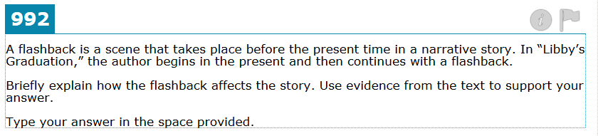

Type your answer in this box.

Type your answer in this box.

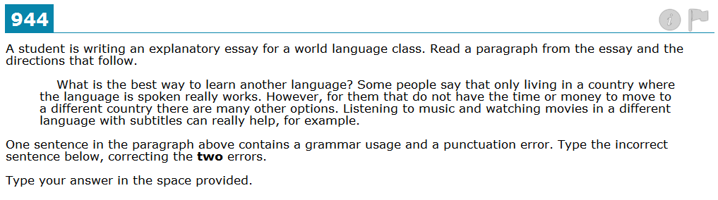

Type your answer in this box.

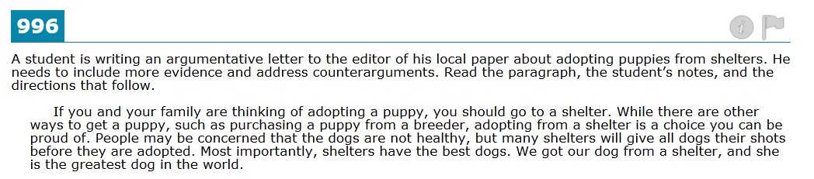

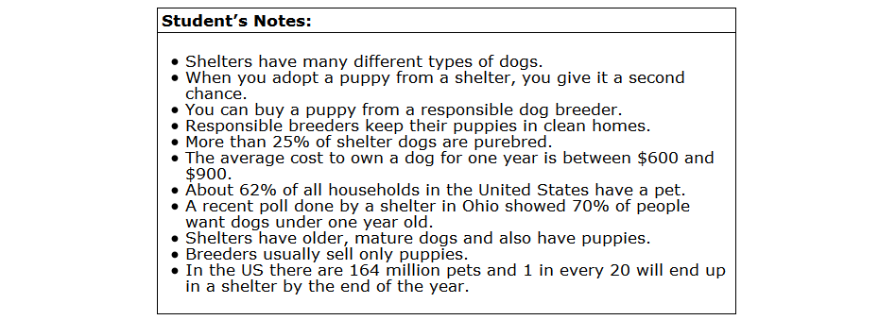

Type your answer in this box.

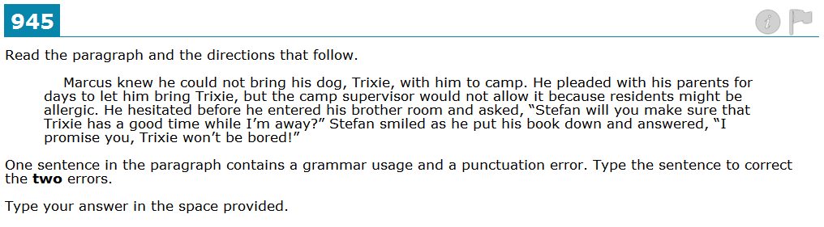

Type your answer in this box.

DOK: 3
Standards: RI-8: The student will make an inference about an author's intention and identify evidence within the text that supports the inference.
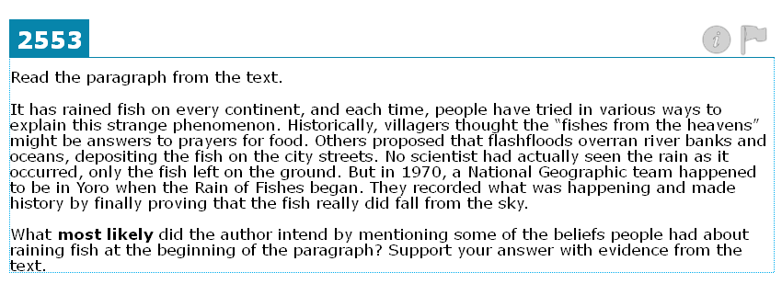

Type your answer in this box.

DOK: 3
Standards: RL-6: The student will form an inference about a literary text and identify details within the text that support that inference.
Type your answer in this box.

DOK: 3
Standards: W-3.b: 1. (Organization) The student will use information provided in a stimulus to write organized narratives that engage and orient the reader by e. providing closure that follows logically from the narrative

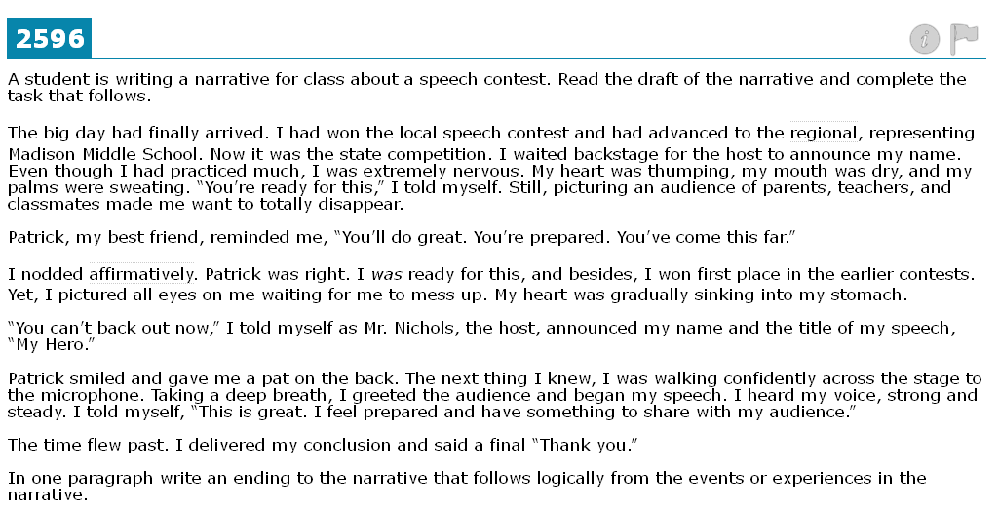

Type your answer in this box.

